AZ 104 – Training

Contents

STORAGE ACCOUNT 2

Blob Storage 2

Azure Files 2

Tables and Queues 3

Container 3

Storage Access Key and Access Key 3

Storage Explorer 3

Log Analytics 3

Copy files with AzCopy 3

Access tiers 3

Lifecycle Management 4

Azure AD Access Control 4

Object Replication 4

IMPORT AND EXPORT DATA TO AZURE 4

Moving Large Files 4

Blob Storage 5

CDN – Content delivery network 5

CONFIGURE AZURE FILES 5

Create Azure file share 5

Azure File Sync 5

Troubleshoot Azure File Sync 5

IMPLEMENT BACKUP AND RECOVERY 5

Azure Backup 5

File Recovery from a VM Backup 6

On-Premises Backup 6

Backup Reports 6

Soft Delete for VM Backups 6

Azure Site Recovery / ASR to Site-to-Site 6

AZURE VIRTUAL MACHINES 6

Create a Virtual Machine 6

Connect to a Virtual Machine 6

VM Availability 6

VM Monitoring 6

VM Custom Script Extension 6

Azure Bastion Service 7

Virtual Machine Scale Sets (VMSS) 7

Azure Compute Gallery 7

Azure Resource Manager - ARM, Automation of Virtual Machines 7

MANAGE VIRTUAL NETWORKING 7

Network Routing 7

Virtual Private Networks – VPN 7

Azure Firewall 8

Virtual WAN & Virtual HUB 8

NETWORKING 8

VNET Peering 8

Azure to Azure Virtual Network Gateway 9

NAME RESOLUTION AND DNS 9

DNS Services 9

Private DNS 9

Public DNS 9

LOAD BALANCING 9

Application Gateway 9

MONITOR AND TROUBLESHOOT VIRTUAL NETWORKING 9

# STORAGE ACCOUNT

Data Lake Storage Gen2

The Data Lake Storage Gen2 hierarchical namespace accelerates big data analytics workloads and enables file-level access control lists (ACLs). Learn more

## Blob Storage

* + Network File Storage (NFS) to mount drives to VMs
  + Access Tier: Hot and Cold

## Azure Files

* + File shares

## Tables and Queues

* + ???

## Container

* + ???

## Storage Access Key and Access Key

* + ???

## Storage Explorer

## Log Analytics

## Copy files with AzCopy

* You can run it like ".\AzCopy "Source URL" "Destination URL"
* Can copy between azure subscription and storage accounts

## Access tiers

* You will be charge by access and storage.
* Premium Tier, it has to be selected at the moment of the storage account creation.
  + It has better performance, it is ten times faster that standard for retrieving data.
* Hot Tier (Default option)
  + You will be charge the standard for access and storage.
* Cool Tier
  + You will be charge half for storage BUT double for access, read, write, view.
* Archive Tier
  + 99 More cheaper to store files that Hot tier, but more expensive to read, write and view, usually for backups
  + It can take several hours to retrieve the data depending on the priority of the rehydration.
* You can change your access tier, at your storage account level or even file level.
* 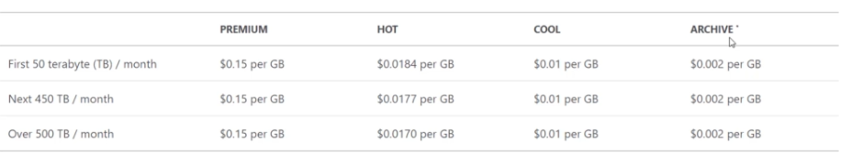

## Lifecycle Management

* Example: You want files to be in hot storage for the first 30 days and then you move them to cool storage
* Policies/Rules to move storage between access tiers, defining the time and access tiers.
* 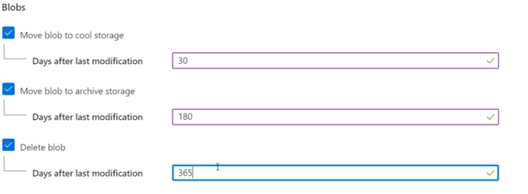

## Azure AD Access Control

* Grant permissions to storage resource to active domain users.
* Storage Account > Access Control (IAM) > Check access >
* Storage Account Contributor to read and write but not to delete

## Object Replication

* Copying data to a different storage account and even to a different region.
* Destination container is read only, this is done by Azure itself.
* You can also create filters.
* Blobchangefeed it indicates the changes done in the storage account

# IMPORT AND EXPORT DATA TO AZURE

## Moving Large Files

* Import/Export
* Export
  + You can export all or just some selected containers and blobs
  + The ship actual HDD to YOU!!
* Import
  + They will send us an empty HDD to upload the DATA!!!
  + Journals…
* Sending the HDD is called Azure Data Box
* Data Box is 100 TB
* Data Box Disk is 8 TB
* Data Box Heavy is 1 PB!!

## Blob Storage

* Storage Account > Performance > Premium
  + Block blobs: best for high transactions rates or low storage latency
  + Files Shares: best for enterprise or high-performance applications that need to scale
  + Page blobs: best for random and write operations
* Only the standard storage account has Geo redundant storage.
* LRS Locally redundant storage, basic protection against server rack and drive failures.
* ZRS Zone redundant storage, protection against datacenter-level failures
* GRS Geo redundant storage, failover capabilities in a secondary region.

## CDN – Content delivery network

* Tbd

## General Purpose V1

## General Purpose V2

# CONFIGURE AZURE FILES

## Create Azure file share

* You can select a quota limit of usage
* You can mount it to a PC

## Azure File Sync

* Synchronize files from local servers into cloud, like a replication service for share files
* You need to download an Azure File Sync Agent
* It is also an object in azure, it is a storage sync service.
* Sync group to select what files are going to be sync between your services.

## Troubleshoot Azure File Sync

* Need to investigate MS KB.

# IMPLEMENT BACKUP AND RECOVERY

## Azure Backup

* Location is important because it must be in the same region as our backup resources.
* It has to applications, Backups and Site Recovery.
* It also works with On-Premises resources using a backup service software.
* Backup for VMs, Azure File Share or SQL server VM.
* You create backup policies, with name with a schedule.

## File Recovery from a VM Backup

* Go to VM > Backup > File Recovery
  + You can download an executable script that will mount the disks from an specific recovery point.
  + Once you have the file you will unmount.

## On-Premises Backup

* You will need the recovery services agent installed in your on-prem machine.

## Backup Reports

* Tbd

## Soft Delete for VM Backups

* 14 days to delete backup data
* Can be un-deleted
* 15th day – auto delete

## Azure Site Recovery / ASR to Site-to-Site

* It will make a copy and will have it ready to deploy to another region (They are sitting and synchronized in case something happens to start the failover)
* Recovery Services Vaults, contain backups and replications.
* ASR Test Failover, azure site recovery test failover
* ASR is cheaper than having two VMs in different locations, but you will still pay for the VM-ASR storage.

# AZURE VIRTUAL MACHINES

## Create a Virtual Machine

## Connect to a Virtual Machine

## VM Availability

* Fault domain, related to physical problem
* Update domain, virtual machines in the same update domain will be restarted together during planned maintenance. Azure never restarts more than one update domain at a time. These are patches from Azure side.

## VM Monitoring

## VM Custom Script Extension

* Extensions for Windows
* Cloud Init for Linux

## Azure Bastion Service

* Secure way to connect to a VM either Windows or Linux
* Bastion server needs his own subnet /26

## Virtual Machine Scale Sets (VMSS)

* Health Probes are available to use
* The training guy from Udemy says it will automatically create a load balancer, but I doubt it

## Azure Compute Gallery

* To store virtual machine images
* It can be shared with RBAC and to public community
* You create the virtual machine images from the Azure Compute Gallery

## Azure Resource Manager - ARM, Automation of Virtual Machines

# MANAGE VIRTUAL NETWORKING

## Network Routing

* Route table, list of IP ranges, it will tell Microsoft how to send traffic to my network

## Virtual Private Networks – VPN

* Private connection, end to end encryption
* Access system by their private IP address
* Point to Site (P2S) VPN
* Site to Site (S2S) VPN
* ExpressRoute
* The P2S and S2S travels over the public internet (encrypted)
* P2S is as simple as installing software on your computer.
* S2S will require physical gateway on your datacenter
* 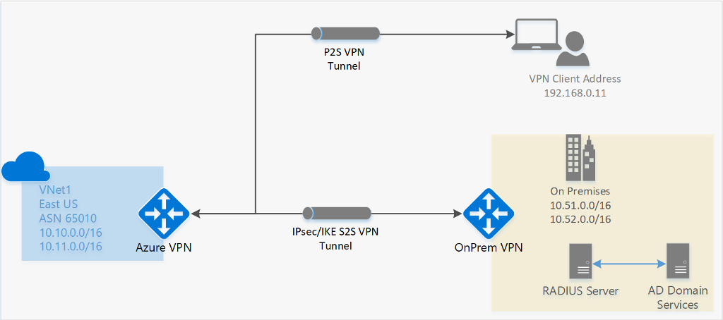
* ExpressRoute is a private connection to Azure, it does not travel over the internet, it is fast and expensive.
* 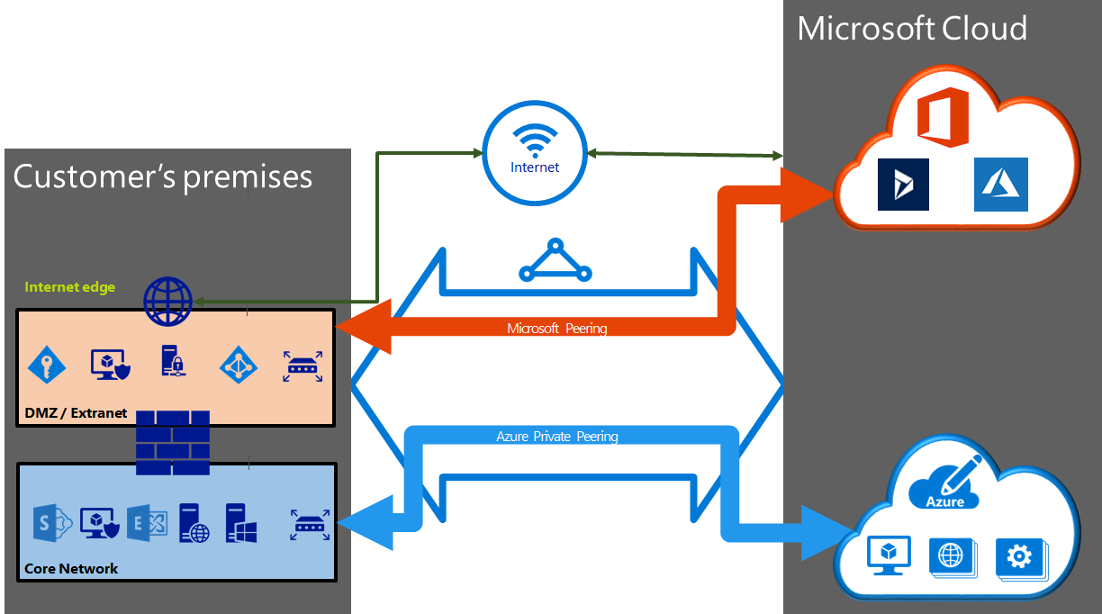
* ExpressRoute Direct, connects directly to Microsoft backbone

## Azure Firewall

## Virtual WAN & Virtual HUB

# NETWORKING

## VNET Peering

* VNET peering does come with a cost for inbound and outbound traffic, the same goes for Global VNET peering.

## Azure to Azure Virtual Network Gateway

* This will work like a VPN or to a VPN

# NAME RESOLUTION AND DNS

## DNS Services

## Private DNS

## Public DNS

# LOAD BALANCING

* A load balancer is a device, that takes traffic in and distribute the traffic according to the algorithm to two or more servers at the backend,

## Application Gateway

* No free Application Gateway
* Enable autoscaling for the application gateway (The LB does not have it)
* In your backend pool you can have an IP, VMs, VMSS or App Services.
* Routing Rule, the listener is like a rule if it success the rule will be applied.

# MONITOR AND TROUBLESHOOT VIRTUAL NETWORKING

## Azure Monitor for Networks

* Connection Monitor

## Network Watcher

* IP flow verify

# MONITOR RESOURCES BY USING AZURE MONITOR

## Azure Monitor

## Logs

* Learn how to do queryis